Investigation of Death: Autopsy

When is an Autopsy Performed?

Whenever the cause of death is ________________________________

Generally speaking, the following circumstances require investigation by law:

1. ___________________________ 2._________________________ 3.______________________

Within 24 hours of entering a hospital or as a result of surgery

A natural death when a doctor is _______________________or the patient is not under the care of a medical facility

Occurs in police custody or in a correctional facility

Results from a ______________________________________ that may pose a threat to public health

In Colorado, counties determine when autopsies are performed. Example from Weld county

Where no physician is in attendance, or where though in attendance, the physician is unable (or unwilling) to certify the cause of death.

All cases in which the attending physician has not been in actual attendance within 30 days prior to death.

All cases in which ________________ may be associated with the death (i.e., falls, _____________________________________ industrial accidents.)

Any patient who has sustained a fracture; no matter how long ago

Deaths by poison or suspected poisoning, chemicals or bacteria, industrial hazardous materials, or radiation.

Known or suspected ____________________________.

Deaths where the deceased has a __________________________________________.

All operating room deaths and deaths which occurring during a medical procedure.

All ____________________________ deaths due to suspicious circumstances.

Deaths which occur within 24 hours of admission to hospital

Autopsy: “___________________________________”

A post-mortem examination of the body, including __________________________ of the corpse.

Performed by a __________________________________ (medical doctor)

3 Steps of a Death Investigation

Preliminary investigation is conducted at the ________________________________

The body is transported to the _________________ where the medical examiner examines the body and performs an autopsy

The medical examiner/coroner ________________________________ on biological evidence collected during the autopsy

At the Death Scene

The death investigator-Employed by the coroner’s/medical examiner’s office

Responsible for;

Initial assessment

_________________ and ______________________ of the body on scene

Position of the body, face (for identification), underside of the body (for lividity, blood, and trace evidence)

Document signs of trauma

Collect information regarding livor and rigor mortis, _________________________________ to help establish time of death

Investigators look for _________________________; any non-biological evidence that provides clues about time of death, (unopened mail, newspaper near the body, etc)

Any evidence collected is properly stored and a ________________________________ is established

Once victim is identified, ______________________________________ and witnesses and the victim’s family are interviewed

______________________________ are placed over the victims ___________________ to protect trace evidence from being lost or preventing cross contamination

Medical Examination

The medical examination is to determine the manner, cause and mechanism of death

2 stages:

1. __________________ Examination

2. __________________ Examination/Autopsy

External Examination

What is examined?

Clothing, boots/shoes, belongings in pockets should be ____________________________________ carefully for storage/packaging

Surface of body

Signs of _______________/x-ray 3. ____________________ scrapings

_______________ samples 4. Fingerprints

_____________________________ evidence collection: Hairs, blood, plant debris, etc.

_______________________________________evidence collection: Glass, soil, artificial fibers, etc

Internal Examination/Autopsy

Estimation of time of death:

Algor, Livor and Rigor Mortis

_________________ contents

____________ (from death scene investigation)

Stages of Decomposition

Fresh 4. __________________________ Decay

_________________ 5. Dry/remains

_____________________ Decay

Fluids Collected

_____________: Collected from femoral artery

______________: Collected from bladder

_________________ Humor: Collected from inside of eye

_____________________-Spinal Fluid

Stomach/Intestinal contents

Stages of Decomposition

Fresh: Livor, algor, rigor mortis, _________________, stoppage, __________________ arrive

Bloat: accumulation of ___________ from microbes, hemoglobin breaks down to form other __________________________ (marbling), maggots hatch, distinctive odors

Active Decay: loss of mass (maggots feeding/purging of fluids, _____________________ and ______________________________________________, strong odors

Advanced Decay: reduced insect activity, _______________________________________________

Dry/remains: resurgence of plant growth, remains=_______________________________________

Types of Autopsy

_________________________________: determine cause and manner of death and identify the decedent

_________________________________: diagnose a particular disease or for research.

Can clarify or confirm medical diagnoses

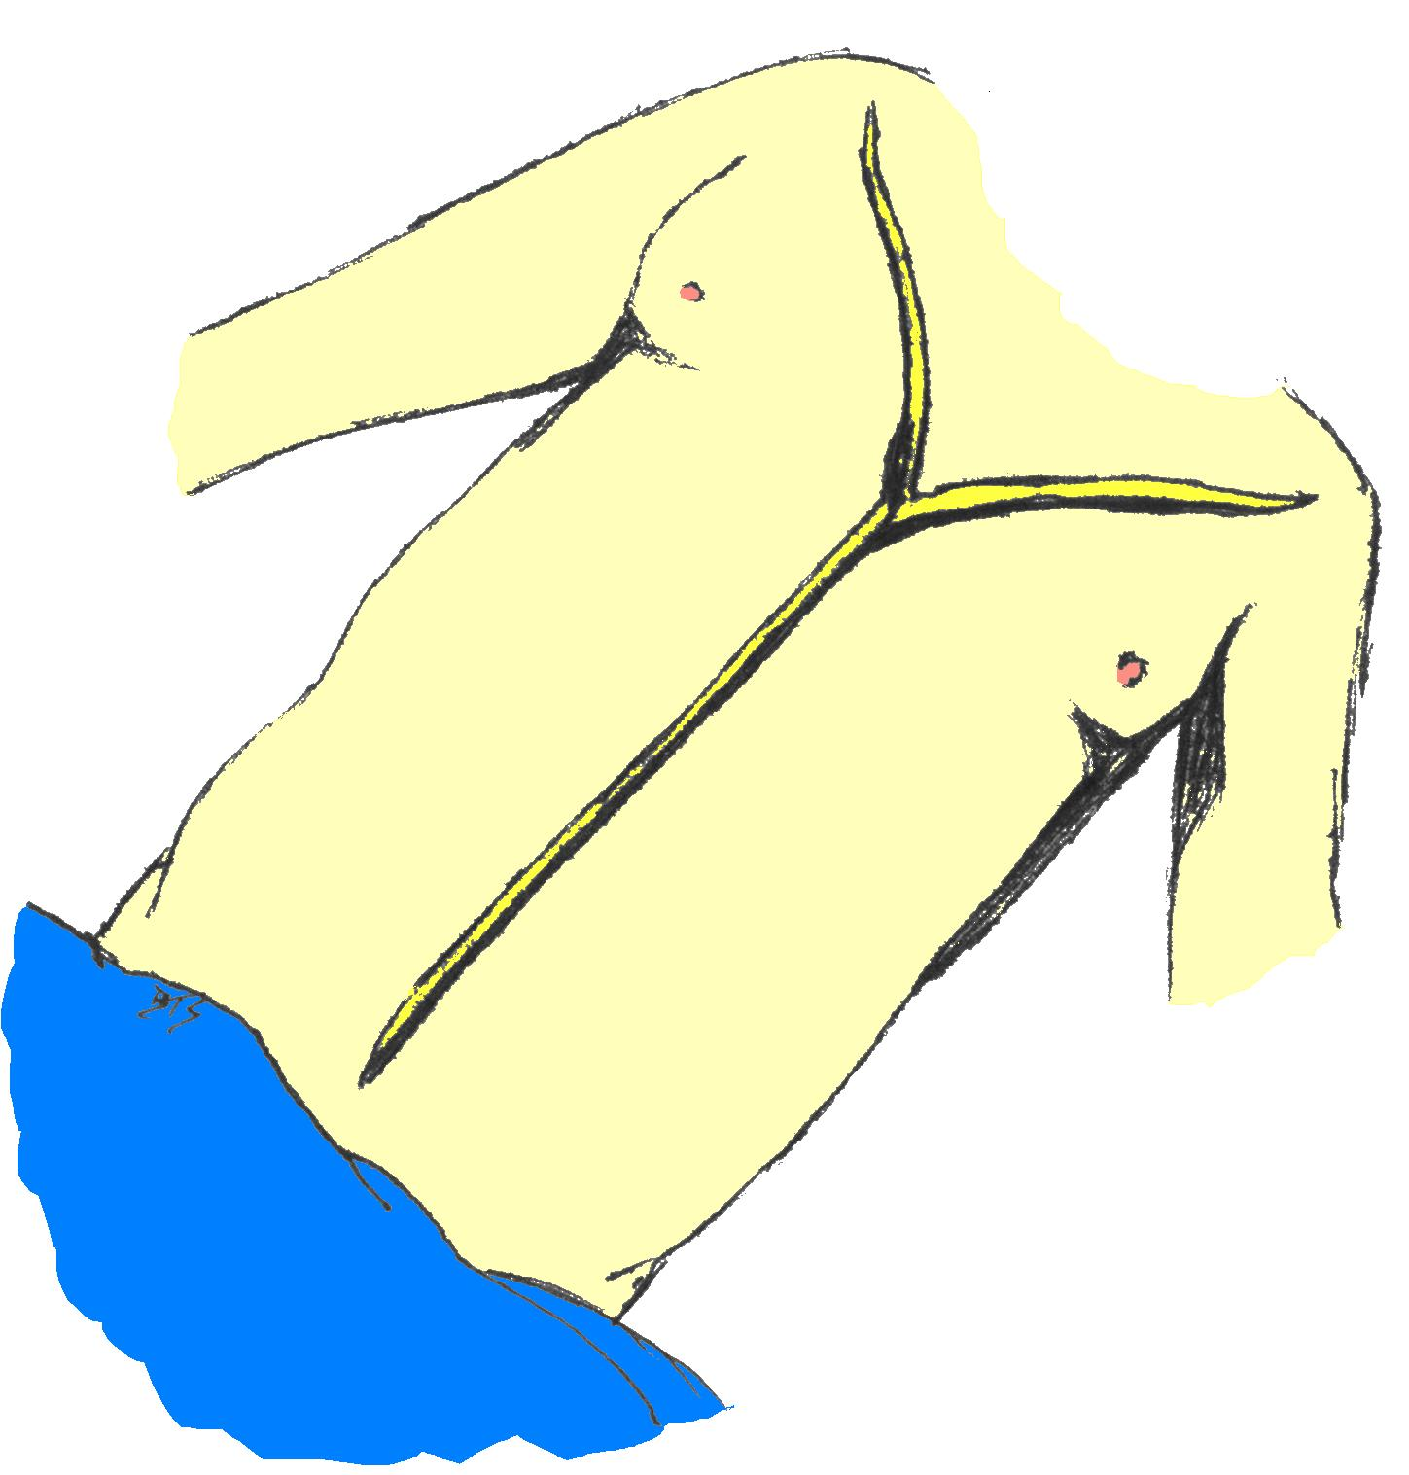
_________________________________: performed by students of anatomy for study

___________________________: performed using MRI’s and CT scans

Autopsy

Trunk dissection;

_______________________ incision

From the shoulders to the pelvic bone

This incision is __________________
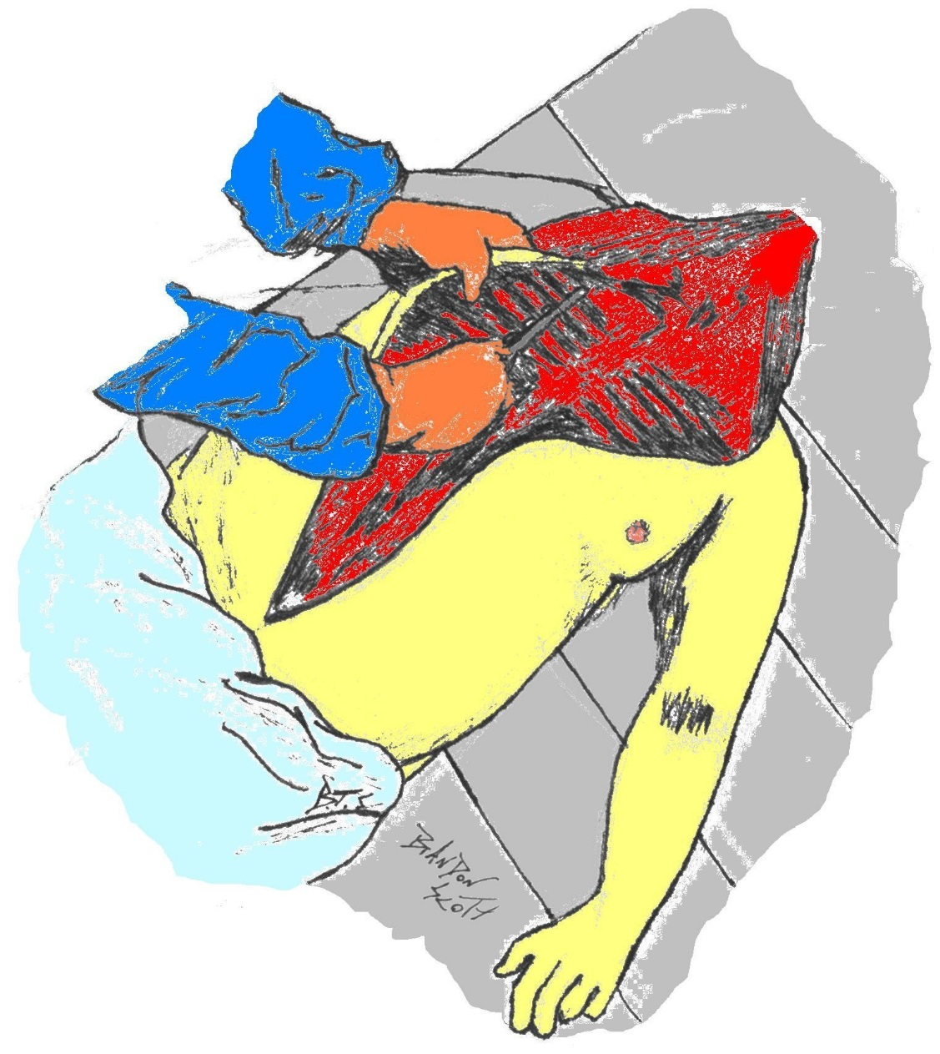

Opening the Chest

Skin & muscle, are pulled from the ___________________________

Chest Plate is extracted

Removal and Dissection of the Organs

Many methods of removal serve different purposes

__________________________ method is an in-situ and en bloc examination of organs intact (still connected to one another)

_______________________ method is an organ by organ removal.

Not great for forensic autopsy-connections are lost between organs

_____________________ method is the En Masse removal of all the viscera (thoracic, cervical, abdominal, pelvic organs) then dissected in organ blocks

Preserves vascular supply and connections between organs.

______________________ method is “En Bloc” removal of organs that are physiologically connected to another, (thoracic, coeliac, urogenital)

After Organ Removal

Upon removal each organ is:

____________ & _________________ - Examined

___________ in cross sections - Sampled for microscopic & chemical analysis

“Running the Gut”

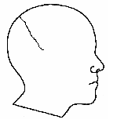
The __________________ of the stomach, intestines, and bowels must be inspected as well

Removing the Brain

The Scalp is cut _____________________

across the ________________ of the head

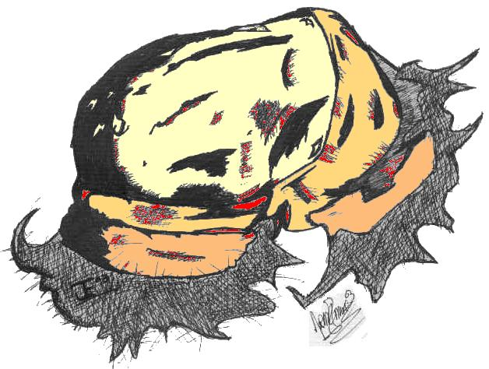

Exposing the Skull

Next the scalp is pulled forward and back to

_________________________________

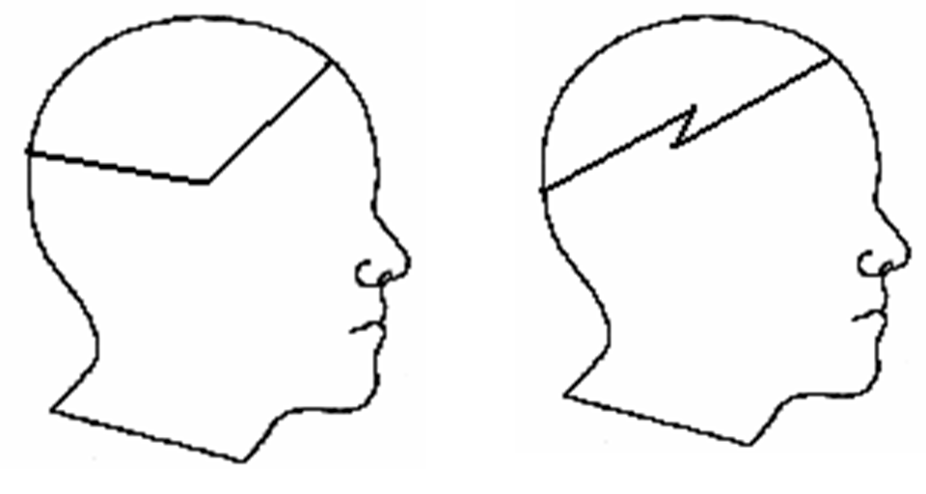
Exposing the Brain

Two methods of cutting the skull cap

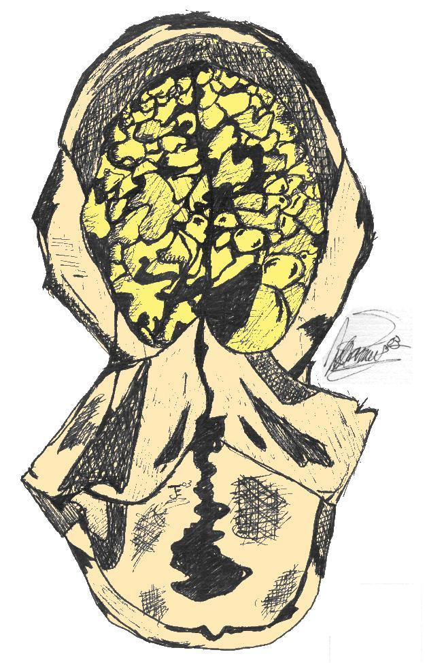
Removal of the Brain

Spinal Cord is cut - The soft ______________ is removed

Brain is so __________ it must be placed

In formaldehyde for about a

____________ before an in depth examination

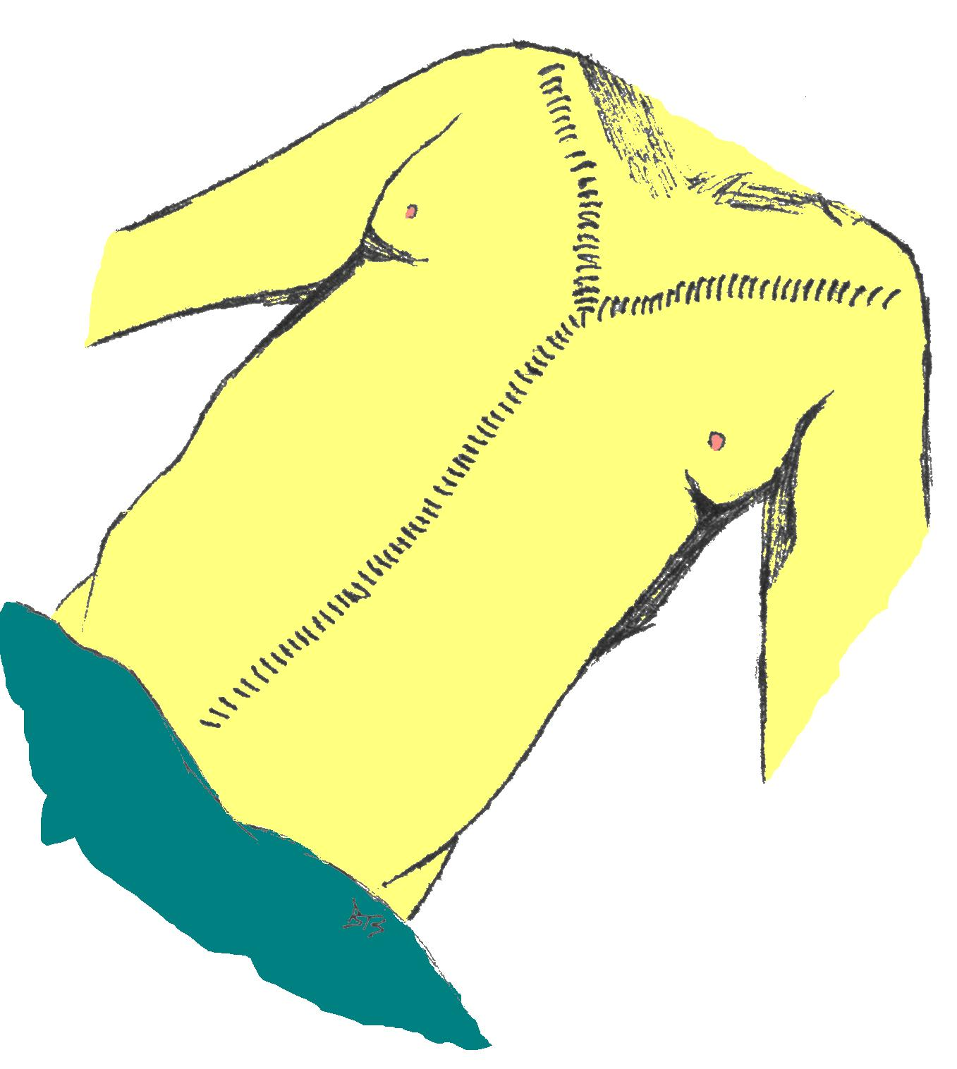
Close Up

_______________________ is replaced

Skin pulled back in place

Body Organs _____________________________ be replaced

Incisions are sown up with the use of a ___________________ stitch

Laboratory Analysis

___________________________: the science related to the detection of drugs, alcohol, and poisons using bodily fluids such as blood, vitreous humor, and urine.

__________________________: the study of _______________. Slides are made of organ tissue to analyze using a microscope. Disease/abnormalities can be detected.

_________________________: the study of __________________________________ associated with the nervous system

__________________: the study of blood, semen, and other body fluids with reference to legal matters

The Autopsy Report

_______________________: Case number, victim info, date/time of death, etc

_________________ Examination : Full description of body & clothing, evidence of disease/trauma

Evidence of Injury: Description of any injuries and record of all __________________________

Internal Examination: Weights and descriptions of all major organ systems and ____________________, findings from toxicology/histology

Medical Examiner’s _______________________________: Cause and manner or death, results and outcomes of tests and examinations

